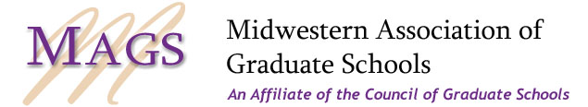

Three Minute Thesis® Regional Competition – Photo Release Form

I hereby grant the Midwestern Association of Southern Graduate Schools permission to use my likeness and 3MT® slide in a photograph, in any and all of its publications, including website entries, without payment or any other consideration.

I understand and agree that these materials will become the property of Midwestern Association of Graduate Schools and will not be returned.

I hereby irrevocably authorize Midwestern Association of Graduate Schools to edit, alter, copy, exhibit, publish or distribute photos for purposes of publicizing the Midwestern Association of Graduate Schools for any other lawful purpose. In addition, I waive the right to inspect or approve the finished product, including written or electronic copy, wherein my likeness appears. Additionally, I waive any right to royalties or other compensation arising or related to the use of these materials.

I hereby hold harmless and release and forever discharge Midwestern Association of Graduate Schools from all claims, demands, and causes of action which I, my heirs, representatives, executors, administrators, or any other persons acting on my behalf or on behalf of my estate have or may have by reason of this authorization.

I am 21 years of age and am competent to contract in my own name. I have read this release before signing below and I fully understand the contents, meaning, and impact of this release.

(Signature) (Date)

(Printed Name) (Date)

